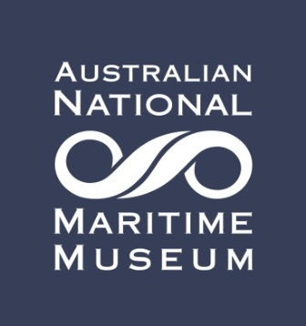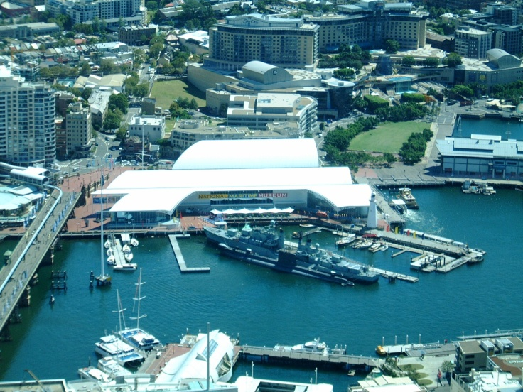
INVITATION
You are invited to a talk on the “The Midget Sub attack on Sydney Harbour” An attack waiting to happen, when the harbor defense preparations were found wanting’

Sydney in early 1942 was a city which expected an attack yet the precautions did not stop two Japanese midget submarines entering the harbor and for a while causing alarm and confusion. They were unlucky not to sink or cause severe damage to some major warships clustered around Garden Island. This fascinating story can now be told in full with all three midget submarines now found.

Your speaker will be James Warrand. . He has been a keen sailor since he grew up on the Pittwater sailing VJ’s, and then owned a small yacht on Sydney Harbour for many years.
His working life included being a dairy farmer and contractor, also as a life insurance and general fire insurance agent, marketing of insurance funding companies and as a financial planner. He has been a volunteer guide at the Maritime Museum for five years and enjoys showing visitors over HMAS Vampire, HMAS Onslow and Bark Endeavour.
James was very involved with the Rural Fire Brigade for over 35 years, and also in several other local organizations.

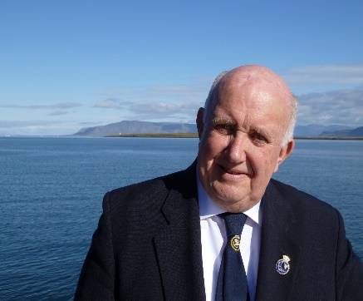

LUCKY DOOR PRIZE
There will be a lucky door prize of a family pass to the Maritime Museum in Darling Harbour valued at $70.

SPECIAL OFFER
Your attendance at this talk entitles you to a SPECIAL OFFER of 20% discount for group tours of over 10 people and 1 year membership. 1 year concessional membership is available for $48 and has the following benefits
- Free entry to the museum every day
- Two guest passes
- 20% discount for 4 guests
- Free tea and coffee in the members lounge
- Subscription to the SIGNALS magazine
- Invitations to events at discounted prices
A great opportunity to take friends and any grandchildren on an exciting day out in a beautiful location.

